VIETNAM NATIONAL UNIVERSITY, HO CHI MINH CITY UNIVERSITY OF TECHNOLOGY

FACULTY OF COMPUTER SCIENCE AND ENGINEERING



Software Project Management

**(CO3012)**

**LAB 1**

**BOOKSTORE MANAGEMENT SYSTEM**

Instructor: Mai Duc Trung

Students: Trinh Cong Vu - 1852882

HO CHI MINH CITY, OCT 2022

LAB 1: Project launch

**Exercise 1**: Learn some open sources that support project management similar to MS Project Although MS Project is one of the most popular software for connecting team’s tasks and planning for projects, there are some alternatives out there. Here are some of them:

1. *SmartSheet*

Smartsheet is a software used to assign tasks, track project progress, manage calendars, share documents, and manage other work, using a tabular user interface as a service offering for collaboration and work management.

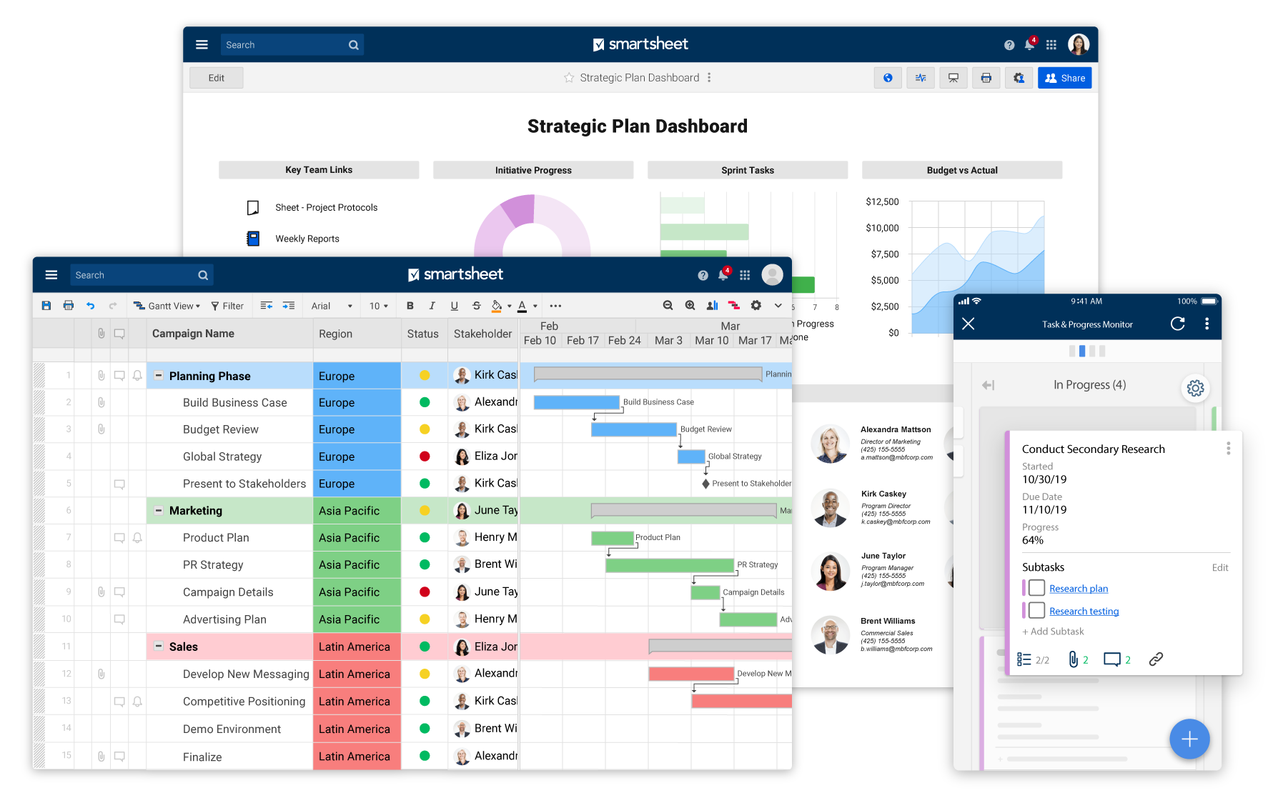

From their website, Smartsheet confirms that it is the only platform that can scale from a single project to end-to-end work management, connecting business on a no-code, cloud-based platform where anyone can create the solution they need — backed by the control and security IT requires.

1. *monday.com*

monday.com Work OS is far more than a project management tool. It is an intuitive platform that helps transform the way teams work together, meet deadlines, and build a culture of transparency.

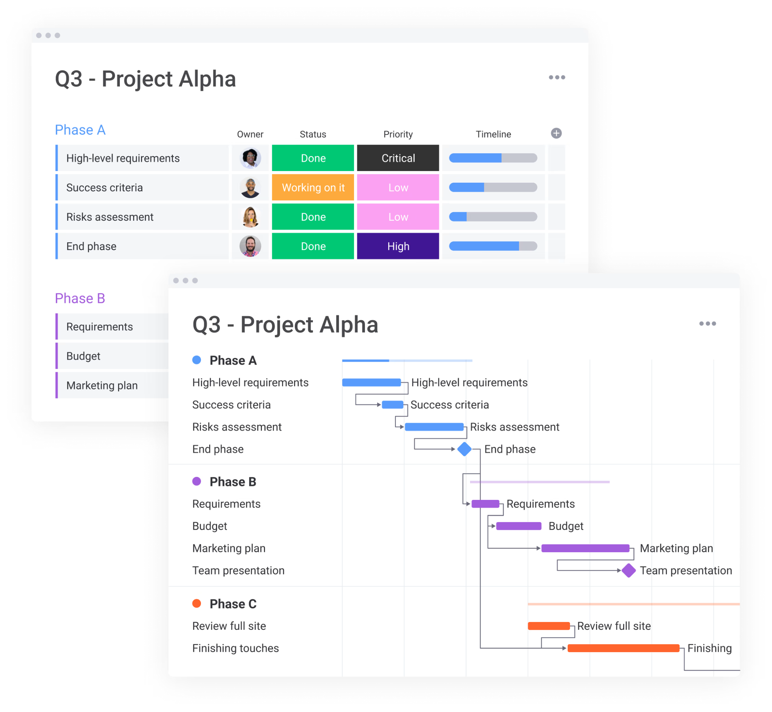

There are many ways to manage a single project in monday.com. It can shape your workflow the way that works for your team - for any project, process, department, or customer. Best things about monday.com are prioritizing what is the most important to your team, setting project timeline, milestones and dependencies and managing your team’s entire workload all in one place.

1. *GanttProject*

GanttProject was born in 2003 and has published countless maintenance and major updates since that time. In 2022, GanttProject still can open documents produced years ago. It is a cross- platform desktop tool for project scheduling and management. It runs on Windows, Linux and MacOSX, it is free and its code is open source.

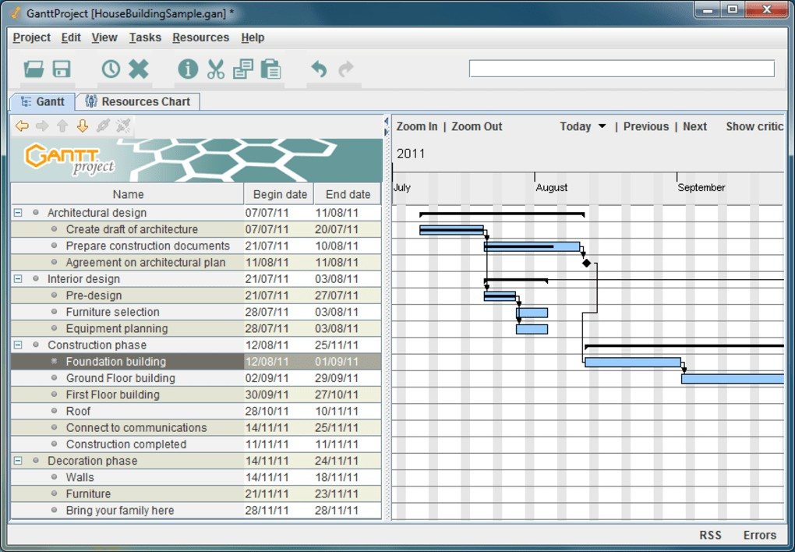

Some key points about GanttProject

* Keyboard friendly : can do many things with the keyboard without using the mouse.
* Easy to Use : Learning curve is very low.
* Clean design : may not be a beautiful UI but neat and clean.

**Exercise 2**: Suppose you are a Project Manager. Create a Project and set a schedule for each team member. **(Bookstore Managament system)**

1. Khoảng 50 nhân viên
2. kho phân phối, có 7 nhân viên quản lí kho
3. mỗi actor như thế nào, lượng tồn kho, doanh thu, thống kê doanh thu theo tháng, quý, năm
   * Nhân viên tạp vụ : 8tr/ tháng + 1tr phụ cấp : 3 người 1 chi nhánh = 9 người = 81tr
   * Nhân viên bán hàng : 10tr/tháng + 1tr phụ cấp : 8 người 1 chi nhắn = 24 người = 264tr
   * Kế toán: 10tr/tháng + 1tr phụ cấp: 3 người = 33tr
   * Quản lí cửa hàng: 13tr/ tháng + 1tr phụ cấp = 1 * 3 = 3 người = 42tr
   * Nhân viên kho: 11tr/ tháng + phụ cấp = 7 người = 77tr
   * Bảo vệ : 8tr/tháng + 1tr phụ cấp 2 người = 6 = 48tr
   * Tổng: 45 nhân viên
   * Mặt bằng: 100tr/tháng * 4 = 400tr
   * Chi phí vận hành : 20tr / chi nhánh + kho = 80tr
     + Tổng lương nhân viên: 545tr/ tháng
     + Tổng chi phí: 1,025 tr / tháng
4. 500tr/3 tháng

App requirement

1. Actor:
   * staff - level 1 : Chấm công
   * staff - level 2: Chấm công, access vào kho sách để xem lượng sách còn, ở chi nhánh nào, vv để chăm sóc khách hàng
   * manager: staff lvl 2 + quản lí staff lvl 1 + staff lvl 2 + kế toán
   * Kế toán: chấm công, access tài chính để kiểm toán, báo cáo
   * admin của system: thêm, bớt nhân viên, vv
   * Chủ: Xem được cả 3 chức năng
2. Chức năng:

* Quản lí nhân viên: tính ngày công, ngày nghỉ, ngày trễ, chấm công, phạt , thưởng doanh thu/năng suất
* Quản lí sách: Quản lí số lượng sách trong kho, số lượng sách bán ra ở từng cửa hàng, số sách bán online
* Quản lí tài chính: Quản lí lượng tiền ra tiền vào, doanh thu của từng chi nhánh, doanh thu online, so sánh doanh thu để người chủ có thể phân tích
* Bán sách: Để nhân viên thu ngân thanh toán và nhân viên sales nhận đơn từ sàn thương mại điện tử.

1. Outcomes :
   * Giúp chủ quản lí nhân viên dễ dàng hơn
   * Giúp tiếp cận nhiều đối tượng hơn với việc bán hàng trên các sàn e-commerce
   * Giúp chủ quản lí tài chính dễ dàng hơn
2. Development cost
   * 4 dev:
     + 1 FE dev: 20tr/ tháng x3 = 60tr
     + 1 BE dev : 25tr/tháng x3 = 75tr
     + 1 Full-stack 25tr/tháng x3 = 75tr
     + 1 Lead : 30tr/tháng x3 = 90tr Tổng 300tr
   * Chi phí hoạt động của hệ thống: 15tr/tháng
   * propose cho khách hàng các mức giá khác nhau, cấu hình thế nào
   * Thưởng cuối dự án : Lead 100tr. Còn lại chia đều cho các thành viên
3. Timeline:

| **Tên công việc** | **Timeline** |
| --- | --- |
| Phân tích các requirement | Tuần 1 (ngày 1-3) |
| Đưa ra các đề xuất khả thi (về công nghệ, phân công nhân lực,…) | Tuần 1 (ngày 4-5) |
| Thiết kế hệ thống (cơ sở dữ liệu, CI/CD, …) | Tuần 2 |
| Hiện thực hệ thống | Tuần 3 - Tuần 10 |
| Kiểm thử hệ thống | Tuần 11 |
| Bàn giao hệ thống + Huấn luyện sử dụng hệ thống + dự phòng | Tuần 12 |

LESSON 2: Planning tasks of the Project

**Exercise 1**: Write a Project Charter and Scope statement:

Project Charter:

* Definition:
  + A project charter states the scope and objectives of a project, as well as the people who will participate in it (stakeholders)
  + Contains most beneficial information about the project to serve as a truthful source of reference
* Outline: A project charter usually has these categories whether altered a bit or not:
  + A brief introduction justifying the project to the business
  + Statement of the project objectives
  + List of high-level project requirements (time, quality, scope and budget)
  + Description of what the end product should be like
  + Known project risks and problems
  + Milestones to meet (including end dates)
  + Expected budget of the project
  + List of stakeholders
  + List of critical success factors
  + Table showing the names and responsibilities of all on the project team

Project Scope:

* Definition:
  + A project scope statement takes the scope from the charter and expands on it.
  + It’s essential that this is done collaboratively with the project team.
  + The audience for this is mainly the team (it's also useful when reporting to stakeholders).
* Outline:
  + What are the project deliverables?
  + What constraints are in place? (team members, technical abilities, …)
  + What assumptions are we making about how well things will go? (Prerequisites)
  + What are the risks to the project? Is there a project member with a highly specialized skill? What happens if they leave? Do we rely on another team delivering their project first?
  + What is out of scope?

Differentiate between **Project Charter and Scope statement :** the charter contains an overview of the project scope and the project scope statement breaks it down into more detail

**Exercise 2**: Giving the following task types:

* You celebrate a birthday or a death anniversary at home. Make a plan to see what tasks will be, how many people are required to work, and how much it costs.

1. **Overview**: A birthday is kind of an important day for everyone.We have about 10 people to participate in this activity.We will prepare for it and it costs about .

#### **Plan** :

* + **Site selection (no cost)** : Choosing place to celebrate the birthday party will affect the the party environment,so we need to take consideration about these factors:

1. Weather condition : Inside the house is more comfortable with the frequent rain.
2. Number of people : family with friends 10 people.
3. Outdoor activity or indoor activity : both
   * **Preparations** (5 people):
   1. Cleaning the house and decorating the house for the party (500k).
   2. Buying food and drink about (300k/person => 3000k).
   3. Birthday cake (500k).
   4. Indoor firework(100k).
   5. Coal for outside bbq parties (50k).
   6. Ballon for decorating house (50k).
   7. Clown (1000k)
   8. Ice and cigarette(100k).

#### Activities

1. Having dinner
2. Playing music and dance
3. Indoor firework and birthday cake celebrating
4. Chatting
5. **Total cost**: about 5 300 000 VND (530 000 VND per person)

* Your family organizes a picnic or camping. Make a plan to see what tasks will be, how many people are needed, and how much it costs.
  1. Overview:

Having a camping or picnic is an exciting and entertaining thing to do. In order to have a rewarding experience, a good plan is indeed necessary.

* 1. Plan:
     1. : Site selection

Choosing a camping or picnic location is utmost important as it will affect camping experience tremendously, choosing a site takes a variety of factors into consideration:

* Camping experience: novice
* Location distance: closer distance lowers the travel cost.
* Number of people: Close Friends, 4 people
* Safety level: established camps or national theme parks have lower risks than those of more remote locations.

With these factors in mind, the ideal location can be Son Tra Peninsula.

2.2: Date selection:

* Create a vote pool for a suitable date, if there is a choice of majority, select the day. In this scenario, the duration can be 2 days.
  1. : Booking in advance:
* Because the peninsula is not belong to anyone, We only have to ask for the Rangers permission, which is easy
  1. : Preparations (5 people):
* Tents renting: 2 tentsfor 2 days: 240k*2 = 480k
* Camping mattress renting: included in the tents
* Cooking stove renting: Brought from home
* Cooking set: self-brought, no cost.
* Fuel: 100k
* Ice carrier: self-brought, no cost.
* Flashlight: no cost.

2.5: Activities:

* Tents build: 2 people per tent
* Set up cooking place: 4 people

2.6: Food preparation (3 people):

* Food: meat, vegetables, fruits, sweets: 400k/person =1200k
* Beverage: 100k/person =400k

2.8: Transportation

Bike: 30k/person = 120k

2.9: Cost incurred:

There will be unknown factors that make cost increase: 100k/person = 400k

* 1. Total cost: 2 700 000đ

4. Cost per person: 2 700 000 / 4 = 675k

* Your company organized a 2-day trip to Vung Tau. Make a plan to determine the tasks and estimate the cost per person.

Overview:

Vung Tau is about 125 kilometers from Ho Chi Minh City. 2 days is kind of short to explore Vung Tau, but enough if we have a clear plan. We will go with about 30 people in 2 days and 1 night.

Plan: including tasks and cost

* + Route selection

Vung Tau possesses a variety of attractions, such as the Front Beach, be Back Beach, Jesus Christ statue, Hon Ba isle and many more

For a company of 30 people, the majority of activities will happen on the beach, along with some sightseeing in famous places. Therefore, the route can be as followed:

* + - Day 1: Arrive at hotel, having lunch and rest, having activities on the beach in the afternoon
    - Day 2: Go sightseeing in the morning, team building activities on the beach in the afternoon
  + Date selection: Create a vote pool for a suitable date, if there is a choice of majority, select the day. In this scenario, the duration is 2 days.
  + Booking in advance:
* Hotel book: (1 person): $10/1 person/ day => $600
  + Preparations:
* Swimsuits: self-brought
* Sunscreen: self-brought
* Beach mat: $3 per mat, 30 people requires at least 10 mats => $30
* First-aid kit: $30
* Personal stuffs: self-brought
  + Activities:
* Team building activities: 20 people
* Sightseeing
* Attendance check: 1 people
  + Food preparation (3 people):
* Food (snacks, lunch and dinner): $15 per person => $300
* Water: 20k/person = $30
  + Site cleaning (30 people):

All members will take part to tidy up the camp site, as it will save a considerable amount of time.

* + Transportation

Booking bus: $10/person = $300

* + Cost incurred:

There will be unknown factors that make cost increase: $5 /person = $150 Total cost: $1590

Cost per person: $1590 / 30 = $53

* Your class has a year-end party or a picnic. Make a plan to see what tasks will be, how many people are required to work, the duties of each person, and how much each person must pay.

Overview

Suppose it is the end of 2022 and for the whole year your class did a really great work. 20 people are going to join our picnic. Our plan is to go to Ba Den mountain and enjoy it there. It is about 110km from Saigon. This venue also allows us to hike and have a picnic altogether.

Planning

Plan: including tasks and cost

* + Route selection: Ba Den mountain has many routes, so it is wise to ask the tour guide to lead the way.
  + Date selection: Create a vote pool for a suitable date, if there is a choice of majority, select the day. In this scenario, the duration is 2 days.
  + Booking in advance:
* Hotel book: (1 person): $10/1 person/ day => $400
  + Preparations (4 people)
* Hiking tools: $50
* Sunscreen: self-brought
* First-aid kit: $30
* Bug, insect repellent: $4
* Personal stuffs: self-brought
* Rent a tour guide: $50 a day => $100
* Tents renting: 5 tents of 4 people for 2 days (($4 + $2)*5 = $30)
* Camping mattress renting: quantity: 2, (($1 + $0.5)*2 = $3)
* Cooking stove renting: $9 for 2 days
* Cooking set: self-brought, no cost.
* Fuel: $5
* Ice carrier: self-brought, no cost.
  + Activities:
* Tents build: 3 people per tent
* Set up cooking place: 3 people
* Hiking
* Cable car travel: $4 per person => $80
* Team building activities
* Sightseeing
* Attendance check: 1 people
  + Food preparation (3 people):
* Food (snacks, lunch and dinner): $15 per person => $450
* Water: $1/person = $20
  + Site cleaning (20 people):

All members will take part to tidy up the camp site, as it will save a considerable amount of time.

* + Transportation

Booking bus: $2.5/person = $50

* + Cost incurred:

There will be unknown factors that make cost increase: $5 /person = $100 Total cost: $1331

Cost per person: $1331 / 20 = $66.53

Your class does charity at a Center for the lonely elderly or provides relief in flood-hit areas. Make a plan to see what tasks will be, how many people are required to work, and how much it costs.

#### Overview

On the trip to do charity at the Center for the lonely elderly, 10 students of our class and the teacher are in charge. They take responsibility for the whole class to make some impact on the place where we are living. The charity will start from the morning till the afternoon and we have raised some money, about 5 million VND. The center has about 15 to 20 lonely elders.

#### **Planning**:

* **Date Selection** : Saturday or Sunday because all of us are students.So we will have weekends for this activity..

#### **Preparation** :

* + Food and drink (2000k)
  + Hire Musical instruments (500k)
  + Decorating stuffs (500k)

#### Activities

1. Cleaning tree downfall
2. Supply food and drink( 3500k). 3 Tai-chi exercise activity.

4 Cooking exercise in the afternoon (400k). 5 Dancing and group talking in the evening .

#### **Transportation**:

Bus : 5k/person => 100k Cost incurred:

There will be unknown factors that make cost increase: 50k /person = 500k.

* Total cost: 5 000 000 VND (500 000 per person)